class05.R

Benjamin

2019-04-16

# Class 5 R graphics  
  
#2A. Line plot  
weight <- read.table("bimm143_05_rstats/weight_chart.txt", header=TRUE)  
  
plot(weight$Age, weight$Weight, xlab="Age (months)", ylab="weight(kg)",   
 main="Weight of Growing Child","l",   
 pch=15, cex=1.5,   
 lwd=2, ylim=c(2,10))

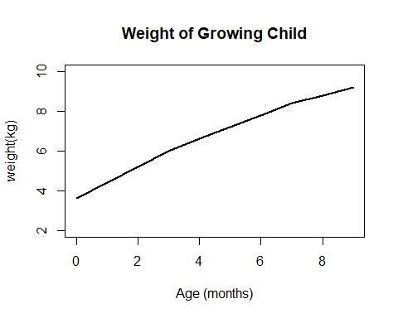

#2B  
features <- read.table("bimm143_05_rstats/feature_counts.txt", sep="\t",header=TRUE)  
features

## Feature Count  
## 1 Messenger RNA 79049  
## 2 Coding Sequences 50770  
## 3 Genes 32029  
## 4 Transfer RNAs 26248  
## 5 CpG islands 13840  
## 6 Pseudogenes 5195  
## 7 Micro-RNAs 1638  
## 8 Small nucleolar RNAs 1602  
## 9 Small nuclear RNAs 1431  
## 10 Miscellaneous RNA 491  
## 11 Immunoglobulin Segments 474  
## 12 Ribosomal RNAs 341

par(mar=c(5,11,4,2))  
barplot(features$Count, horiz=TRUE, names.arg = features$Feature,las=1)

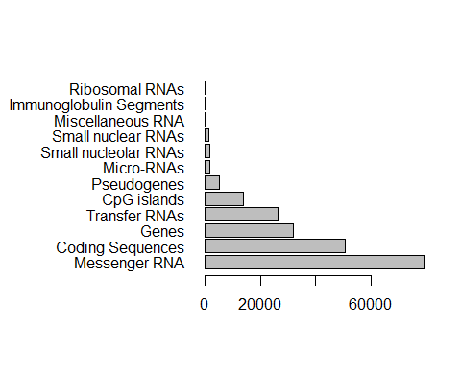

#3A  
gender <- read.delim("bimm143_05_rstats/male_female_counts.txt", header=TRUE)  
gender

## Sample Count  
## 1 D1 Male 2  
## 2 D1 Female 1  
## 3 D2 Male 2  
## 4 D2 Female 3  
## 5 D3 Male 3  
## 6 D3 Female 6  
## 7 D4 Male 5  
## 8 D4 Female 10  
## 9 D5 Male 9  
## 10 D5 Female 18

par(mar=c(7,4,4,2))  
barplot(gender$Count, names.arg=gender$Sample, las=2, col=c("pink","plum"))

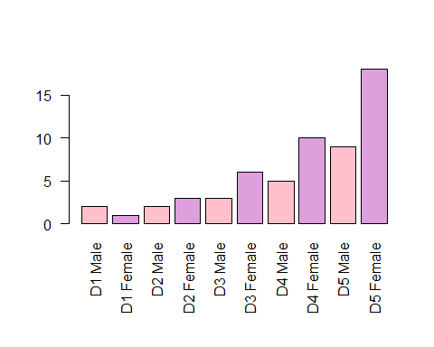

barplot(gender$Count, names.arg=gender$Sample, las=2, col=c(1,2))

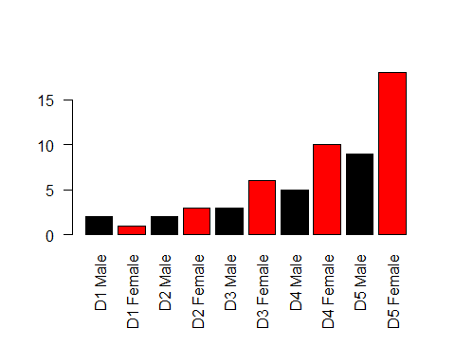

barplot(gender$Count, names.arg=gender$Sample, las=2, col=(rainbow(10)))

